

Housing Trust Golf Day Fundraiser 27/05/2022
Terms and Conditions of Entry
Please read the Terms and Conditions of entry into the Illawarra Community Housing Trust Ltd. golf Day Fundraiser prior to entry. Your inclusion in this event is subject to you accepting these Terms and Conditions.
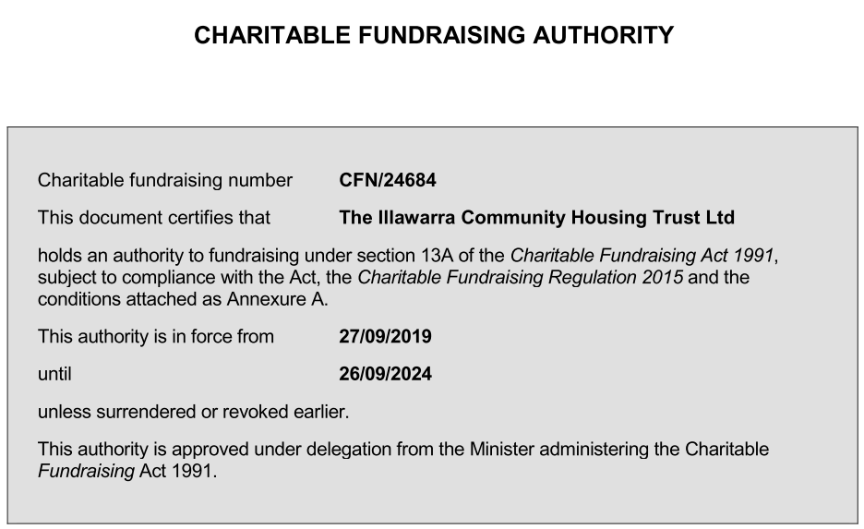
Housing Trust is a holder of an Authority to appeal for public funds, subject to the obligations set out in the Charitable Fundraising Act of 1991 (the Act) and the Charitable Fundraising Regulation 2015.
All funds raised will contribute to the Housing Trust Tylah West Education Scholarship.
All participants must abide by Wollongong Golf Club Player Rules, Code of Conduct and Dress Code. Please contact the club 02 4222 3114 https://www.wollongonggolfclub.com.au/ for more detail.
COVID safe measures must be observed at all times. For up to date information please go to https://www.health.gov.au/
Housing Trust regularly carries out public relations, communication and marketing activities to generate support and maintain a strong profile in the community, and raise awareness about community housing. This is usually communicated with images, recordings, video footage and interview materials using media such as our website, newsletter, and social media platforms such as Facebook, twitter, annual reports, newspaper articles, television reports, and flyers. These materials are handled as outlined in Housing Trust’s Privacy Policy which is available on our website https://housingtrust.org.au/about-us/policies/ or by contacting our office on 02 4254 1166. Your participation in this event indicates your acceptance of the use of such media.

Whilst there is an entry fee into the tournament, there is no entry fee for the major prize. Entry is by invitation only. Raffle tickets are purchased separately to entrance fees and the trophies are awarded to the first, second and third place holders. Housing Trust staff selling raffle tickets will have identification on them so participants can easily recognise persons with authority to fundraise.

Please note changes to amateur status rules in relation to major prizes https://www.golf.org.au/amateurstatus/

Prizes
Hole in one on 5th Hole:
If a Housing Trust fundraiser registered golfer hits a hole in one on pin number 5 they will win a brand new car valued at a minimum of $22,000. This is a Free Lottery as described by NSW Fair Trading and a game of skill. Should more than one person hit a hole in one, there will be a play off.
Each person will have to tee off on the same spot aiming for the same pin, and the person whose ball is closest to the hole will win the car.
The Supervision Guide must be adhered to with at least one independent, non-playing witnesses over the age of 18. This person will be a Housing Trust staff member.
There is a maximum of 1 shot per person only.
Standard PGA equipment must be used.
The hole will not be modified from its original state for this event.
Raffles:
There will be numerous prizes raffled on the day. This is a draw lottery and a game of chance. Tickets will be sold and drawn on the day. Raffle tickets may be purchased before the day. Raffle closes at lunch on Friday 27/05/2022. Winners will be randomly drawn near the conclusion of the event. Winners do not have to be present. Housing Trust will provide the prizes to winners within two weeks of the draw.
Trophies:
First prize perpetual trophy will be awarded to the group with the lowest total score. The trophy will be held by the Housing Trust until the following Housing Trust Golf Fundraiser. Other prizes may be distributed by Housing Trust on the day.
Second prize trophy (four) will be awarded to the group with the second lowest total score. These trophies may be kept by the recipients. Other prizes may be distributed by Housing Trust on the day.
Third prize trophy (four) will be awarded to the group with the third lowest score. These trophies may be kept by the recipients. Other prizes may be distributed by Housing Trust on the day.

