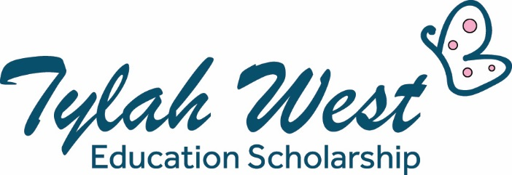

TYLAH WEST EDUCATION SCHOLARSHIP GUIDELINES 2023
OPENING DATE: October 4th 2022
CLOSING DATE: November 4th 2022
APPLICANTS INFORMED OF OUTCOMES: November 22nd 2022
PRESENTATION: TBA
SCHOLARSHIP VALUE:
Primary aged students – up to $500
High school students – up to $750
Mature age students/trainees/new employees – up to $2,000 based on needs
Please read and retain the guidelines below before completing your application online at:
www.housingtrust.org.au/TWES2023Application
The Tylah West Educational Scholarships provide assistance with the costs of education, training and gaining employment to Housing Trust tenants.

The Scholarships are named in memory of Tylah West who participated in Housing Trust’s Aboriginal Traineeship Program. Tylah’s vibrant personality left a lasting impact on all who knew her. The scholarships were created with the support of Tylah’s family and have provided assistance to nearly 100 Housing Trust tenants since 2017.

Who is Eligible?
- You must be an approved tenant or resident in a Housing Trust property
- Be studying or training in 2023
- Be starting a new job, apprenticeship or traineeship in 2023
- Attend primary or high school in 2023
- Not be in receipt of any other scholarships in 2023
- More than one household or family member may apply
- There are no age restrictions for applicants
- Previous recipients are welcome to apply

Types of expenses the scholarship may cover:
- School, TAFE, college or university fees
- School excursions and school sports fees
- Tutoring
- Computer equipment (maximum $750)
- Office equipment and supplies
- Textbooks
- Uniforms or work wear
- Tools
- Transport
Other items may be discussed with the scholarship team. Mobile phones cannot be purchased with the scholarship funding.

Assessment Criteria
Applicants will be required to do the following:
- Submit a fully completed application by 4th November 2022 (see link above)
- Demonstrate their capacity to undertake work or study
- Demonstrate their commitment and enthusiasm to obtaining work or study
- Outline their goals and what they hope to achieve
- Provide evidence of the cost of the items or course applied for if applicable
- You may be required to attend an interview with the scholarship team
- Commit to attend the scholarship presentation in 2023

What happens if my application is successful?
- You will receive an email or letter stating the amount of scholarship funding you have been awarded
- You will receive a direct credit form that will need to be filled out and returned to Housing Trust
- Funding will be available mid January 2023
- Recipients applying for tuition, computers or equipment will need to provide an invoice/quote which Housing Trust will pay direct to the supplier
- School children will be allocated funding at the beginning of terms 1 and 3
- Recipents will be required to provide feedback during and at the conclusion of the scholarship
- All Scholarship winners will be required to attend a presentation in the first half of 2023. Future scholarships will not be considered if recipients decline
- Scholarship recipients will be required to assist in promotion of the scholarship and agree to have their photo taken and be videoed. Recipients are aware Housing Trust can use this promotional material as required

Should you have any questions please call our team at Housing Trust on 4254 1166 or email TWES@housingtrust.org.au

